**WAPH-Web Application Programming and Hacking**

**Instructor: Dr. Phu Phung**

**Mini Facebook**

**Team – 01**

**Team members**

1. Tulasiram Nakkanaboina, [nakkantm@mail.uc.edu](mailto:nakkantm@mail.uc.edu)

2. Vihasith Rasala, [rasalavh@mail.uc.edu](mailto:rasalavh@mail.uc.edu)

3. Grahika Rampudi, [Rampudga@mail.uc.edu](mailto:Rampudga@mail.uc.edu)

4. Sai Sandeep Pasham, [pashamsp@mail.uc.edu](mailto:pashamsp@mail.uc.edu)

*Team members respective headshots*

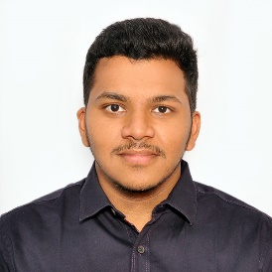  

**Project Management Information**

Source code repository (private access):[**Click_here**](https://github.com/waph-team01/waph-teamproject)

Project homepage (public): [**Click_here**](https://github.com/waph-team01/waph-team01.github.io)

**Revision History**

|  |  |  |
| --- | --- | --- |
| Date | Version | Description |
| 26/03/2024 | 0.0 | Initial draft |
| 31/03/2024 | 0.1 | Drafting template overview |
| 01/04/2024  22/04/2024 | 1.0  2.0 | Sprint 1 update  Sprint 2 update |

**Overview**

The primary focus of the WAPH project revolves around creating an all-encompassing web application named "MiniFacebook." The development process of this web application incorporates comprehensive full-stack web development techniques and cybersecurity principles to ensure its resilience against potential vulnerabilities exploited by hackers. Our team, comprised of four classmates, collaboratively worked on the website's development. We primarily utilized WhatsApp for communication, supplemented by in-person meetings for discussions. Additionally, we employed collaborative note-taking tools accessible to all team members, facilitating project discussions, idea generation, and progress tracking.

**System Analysis**

During the initial phase that is for the sprint 0 of the project, we constructed the website utilizing the system configuration file, which was utilized and modified for the WAPH-team project file. The hosts file in the etc folder was updated with the public URL: [waph-team01.minifacebook.com](https://waph-team01.minifacebook.com/) alongside the IP address.

**Demo screenshots**

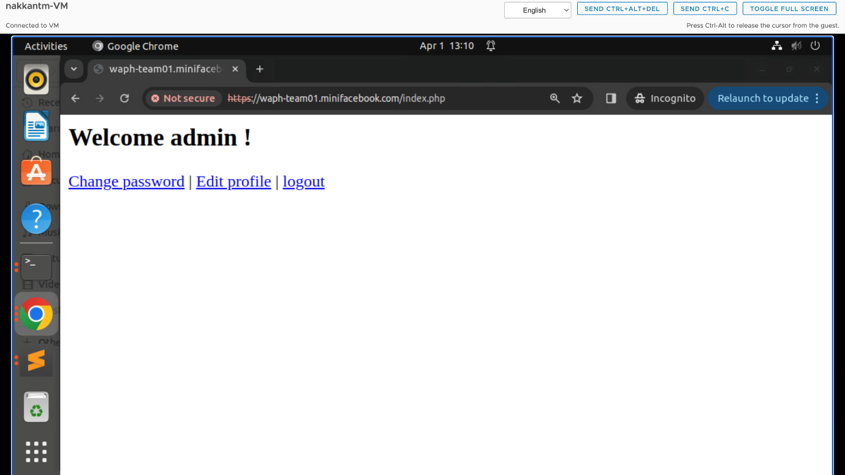

Figure login admin page

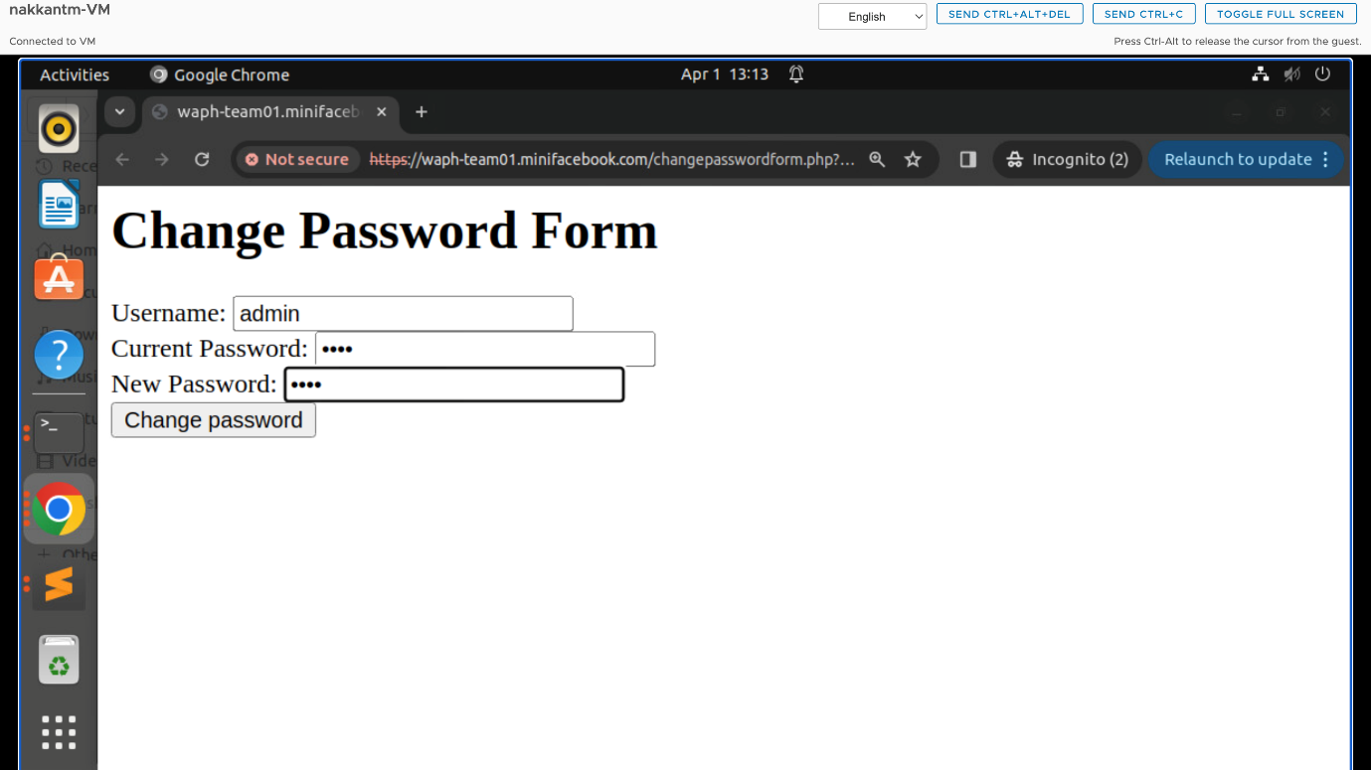

Figure change password form

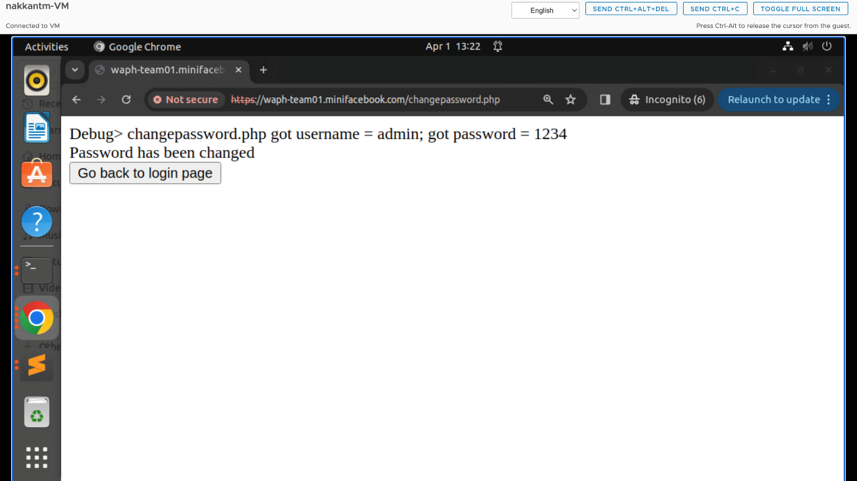

Figure password changed successfully

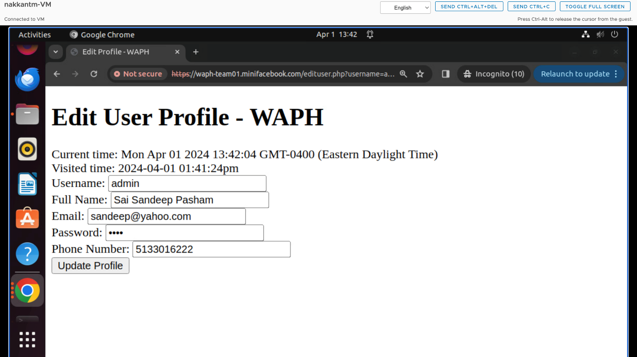

Figure edit user profile

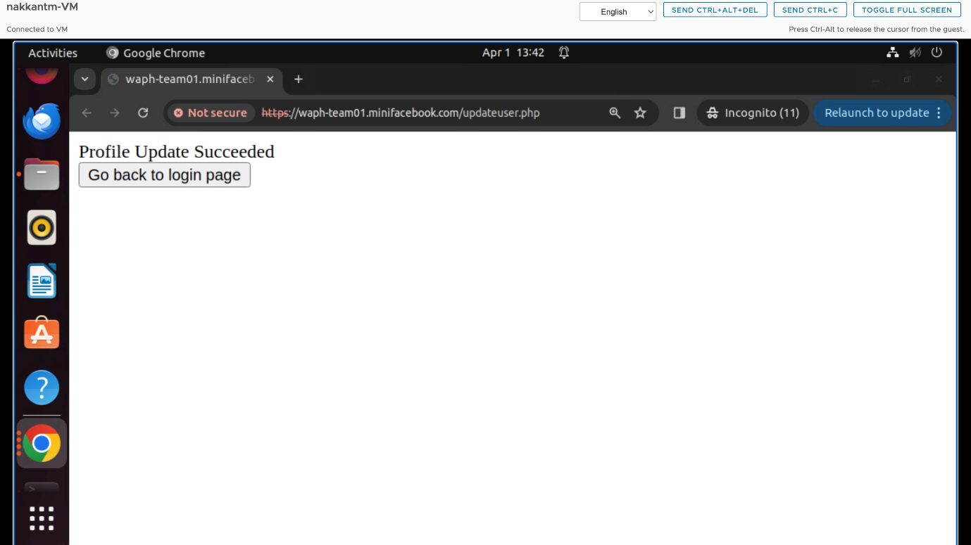

Figure update profile

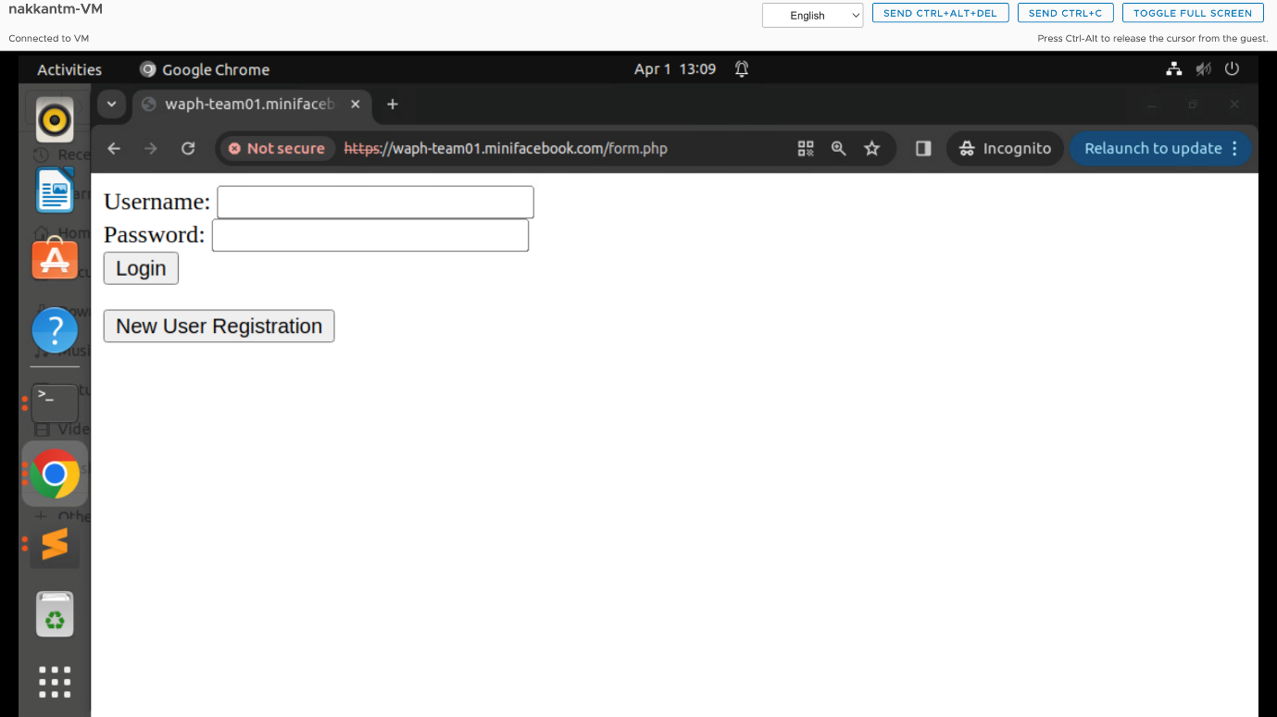

Figure login page

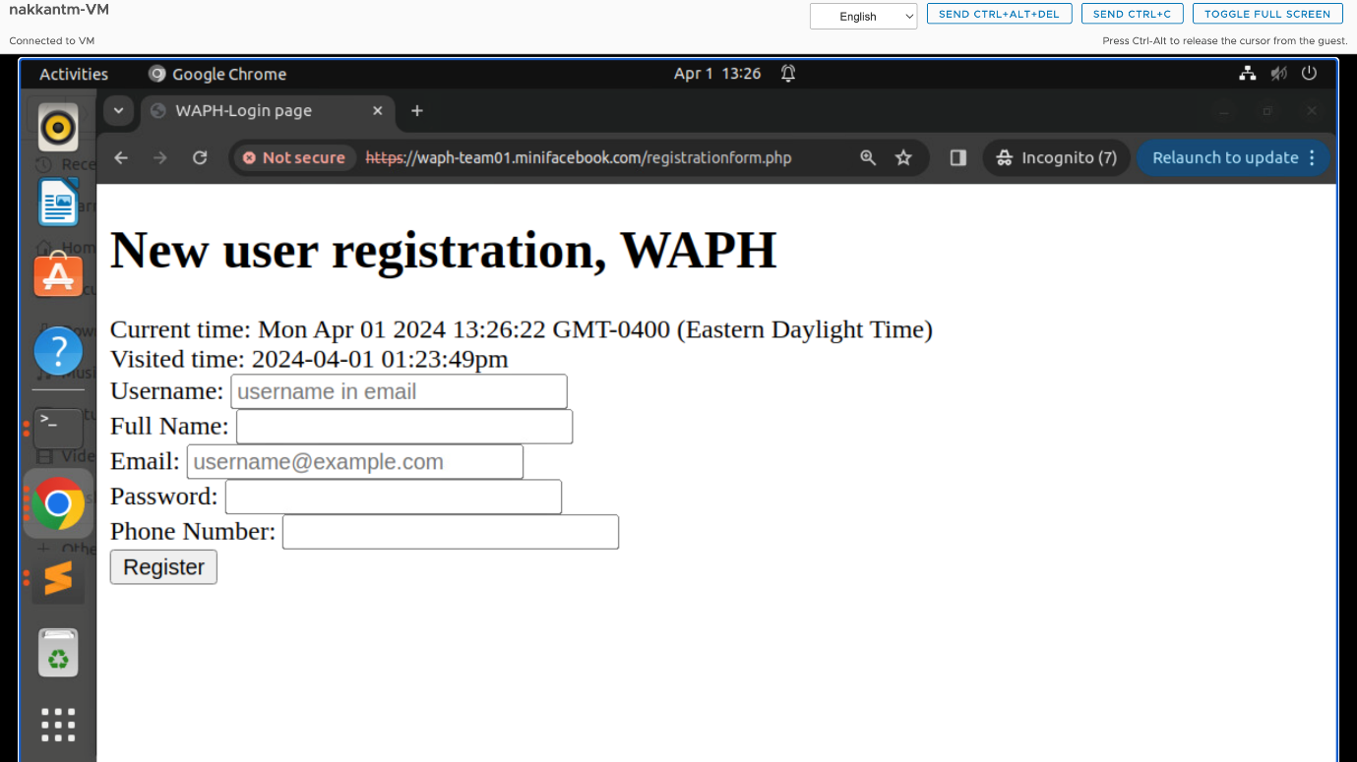

Figure new user registration form

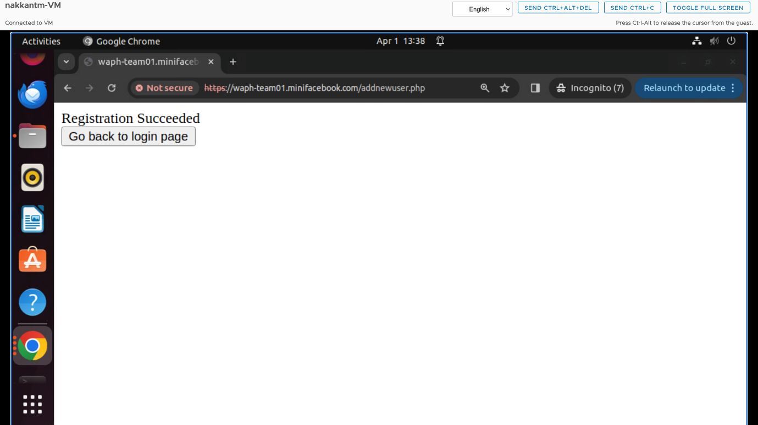

Figure succesful registation form

**Functional Requirements**

* **Features for posting like images and texts:** Enabling users to create and share posts with images/texts.
* **Database setup:** Configuring database system for storing application data securely.
* **Notification add on:** Implementing notification system for relevant user alerts.
* **Forms for authentication and user registration:** Implementing secure login and registration forms for user access.
* **Search functionality:** Enabling users to search for specific content within application.
* **Messaging features:** Integrating private messaging functionalities for user communication.

**Non - Functional Requirements**

* **Error handling:** Managing errors for smoother user experience and application stability.
* **Implementing security features:** Strengthening application security through implementation of various security measures.
* **Cookies:** Utilizing cookies for managing session information and enhancing user experience.
* **Session information:** Handling session data to maintain user context and interactions.

**Database**

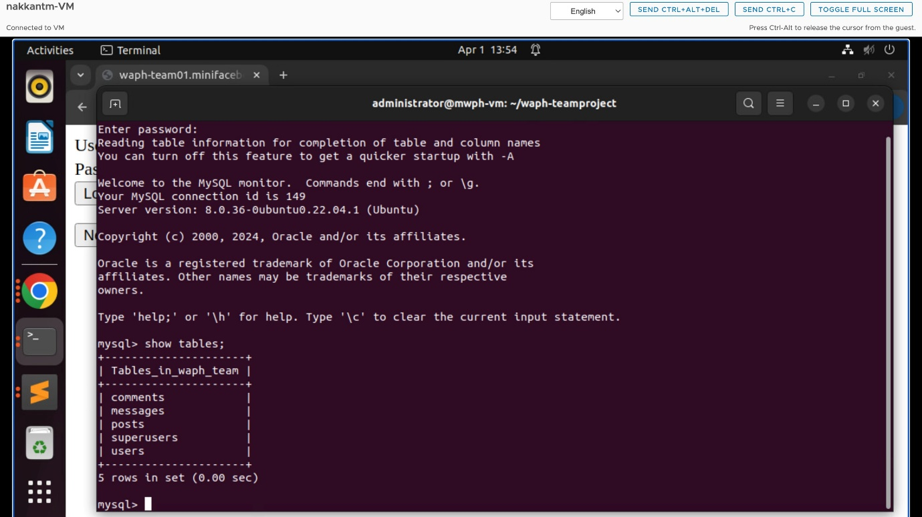

Figure tables which stores the data

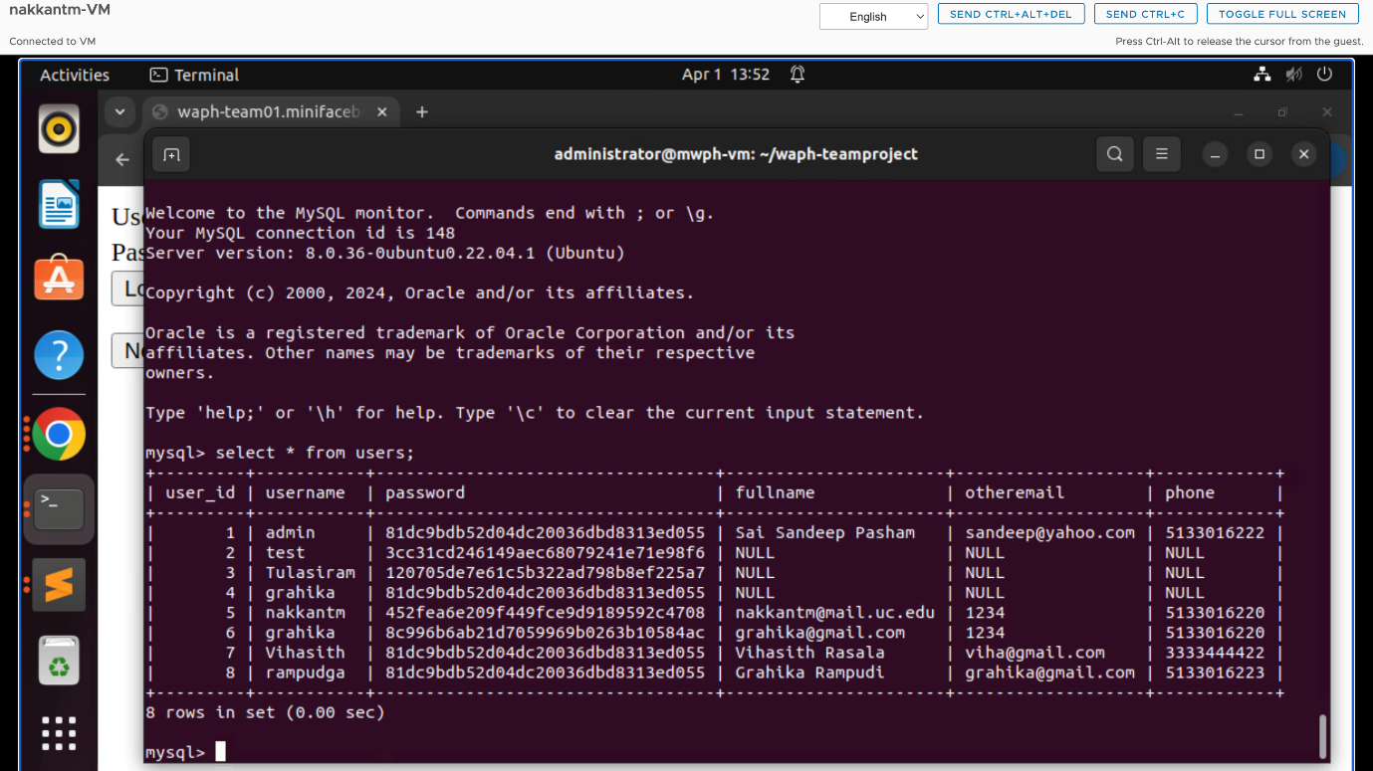

Figure user tables

**User Interface**

**Front-End:**

**Edit Profile Feature:** Users can modify their full name, email, and phone number.

**Change Password Option:** Users can change their password if facing any issues.

**Posts Visibility Setting:** Upon logging in, users can view site's posted content.

**Back-End:**

**Database Creation:** Established a database with essential tables for the application.

**Users Table:** Stores user information including full name, username, password, email, and phone number.

**Posts Table:** Records posts from various users, containing fields like Post ID, Title, Content, Post Date, and Owner.

**Database Integration:** Connected the database with the front end to save user inputs.

Implementation

**Security Analysis**

**Scrum Process**

**Sprint 0**

Duration: 03/22/2024-03/31/2024

*Completed Tasks:*

1. Our team has successfully established both public and private repositories

named “waph-teamproject” and “waph-team01.github.io” correspondingly.

2. SSL certificates and keys for the team project have been generated.

3. HTTPS has been configured within the local domain name to ensure secure

communication.

4. A database has been set up for the system.

5. Individual home pages have been developed for all team members, and

their respective lab files have been transferred to the team directory.

6. Testing of the index.html page has been carried out, yielding the anticipated

performance and functionality as observed during the tests.

*Contributions:*

1. Tulasiram Nakkanaboina, 11 commits, 7 hours, contributed in generating

the SSL keys and certificates.

2. Vihasith Rasala, 8 commits, 6 hours, contributed in documentation of

README file and organizing the data.

3. Grahika Rampudi, 8 commits, 7 hours, contributed in creating the personal

page of our team which includes details of our team members.

4. Sai Sandeep Pasham, 7 commits, 6 hours, contributed in creating the

database-data.sql, index.html page which includes the details of admin

login.

**Sprint 1**

Duration: 03/28/2024-04/01/2024

*Completed Tasks:*

1. Established the database according to the outlined criteria.
2. Developed both login and registration forms.
3. Executed fundamental features for authenticated users, such as password modification.

*Contributions:*

1. Tulasiram Nakkanaboina, 11 commits, 7 hours, contributed in creating user registration and profile edit php files snd further developed index.php file

2. Vihasith Rasala, 15 commits, 6 hours, contributed in documentation of

README file and organizing the data. Created and developed logout php file.

3. Grahika Rampudi, 8 commits, 7 hours, contributed in creating and organizing the database and it’s implementation in back end of web application.

4. Sai Sandeep Pasham, 7 commits, 6 hours, contributed in creating the change password and login php files.

**Sprint 2**

Duration : 04/15/2024-04/22/2024

*Completed Tasks:*

1.Updated the database design and implemention to incorporate new posts,edits, deletion and user management access.

2.Logged-in users can add a new post, and add a comment on any post

3.Logged in users can edit their own post and the user cannot edit post o other users.

*Contributions:*

1. Tulasiram Nakkanaboina, 22commits, 14 hours, contributed in creating usermanagement.php and updated index.php, viewprofile, edituser php files ,modified style.css to give new appearance to the application.

2. Vihasith Rasala, 18 commits, 10hours, contributed in updating the Edituser.php, viewpost.php, addpost.php, and insertpost.php.

3. Grahika Rampudi, 19commits, 11 hours, contributed in updating the index.php, deletepost.php, edituser.php, database.php.

4. Sai Sandeep Pasham, 17 commits, 9 hours, contributed in updating addcomment.php , Insertpost.php, edituser.php, Index.php and documentation of README file and organizing the data.

**Sprint Retrospection**

* The main problem we faced for a team call is unmatched schedule of team members. We are usually doing our team meetings in late nights.
* Online calls didn’t meet the expected progress of the project, so we are making ourselves available for physical sessions which is difficult.
* Proper collaborative dashboards require premium subscriptions for third party applications.
* Sandbox doesn’t work properly which is a dot in a white page.
* Team members use different OS like MacOS or windows where it’s difficult to work in virtual machine setup if it’s a Macbook.

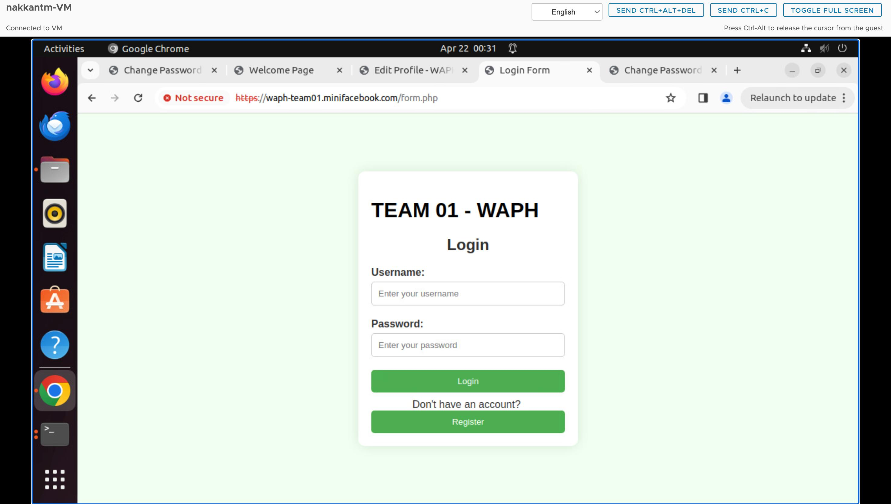

Figure login page

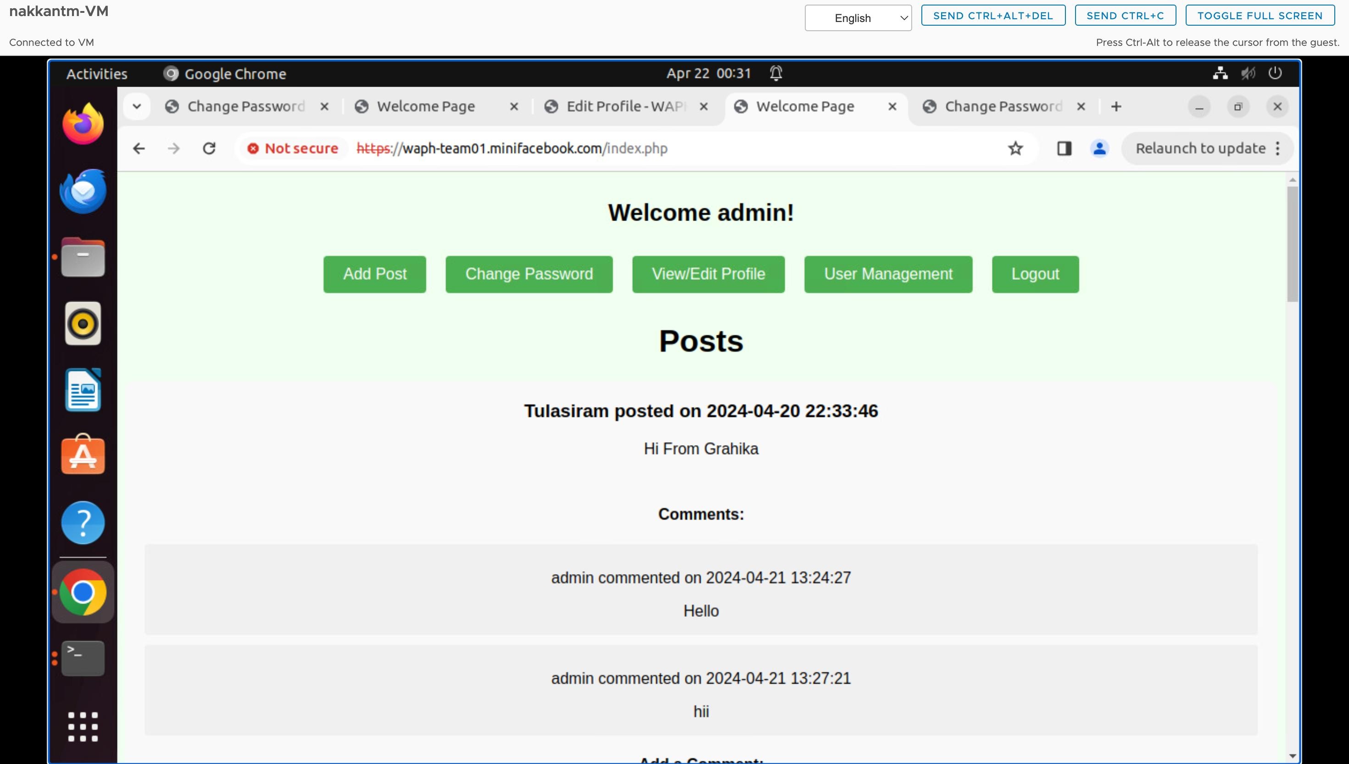

Figure Homepage where user can view all the posts

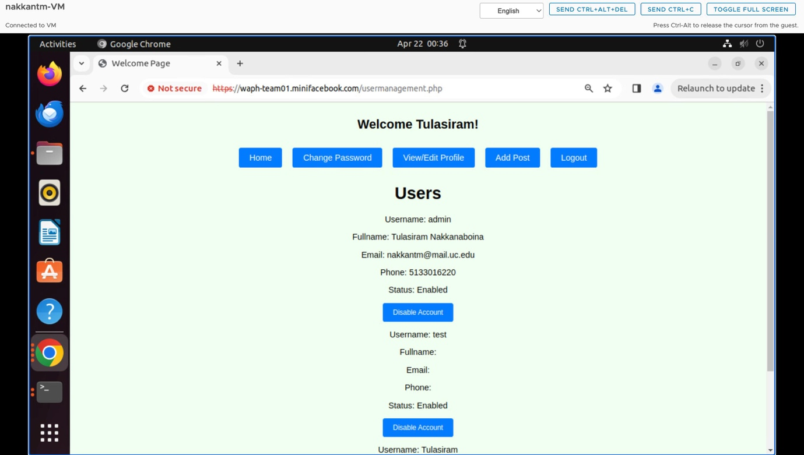

Figure usermanagement page

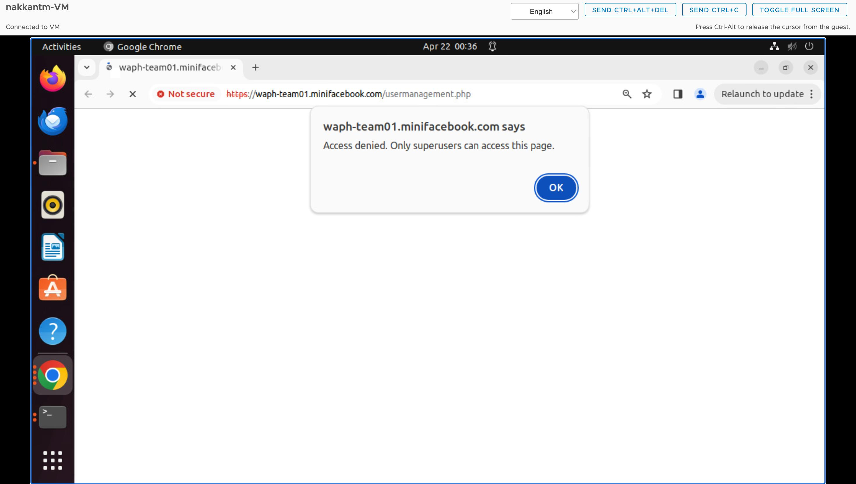

Figure only superusers can access the usermanagement page

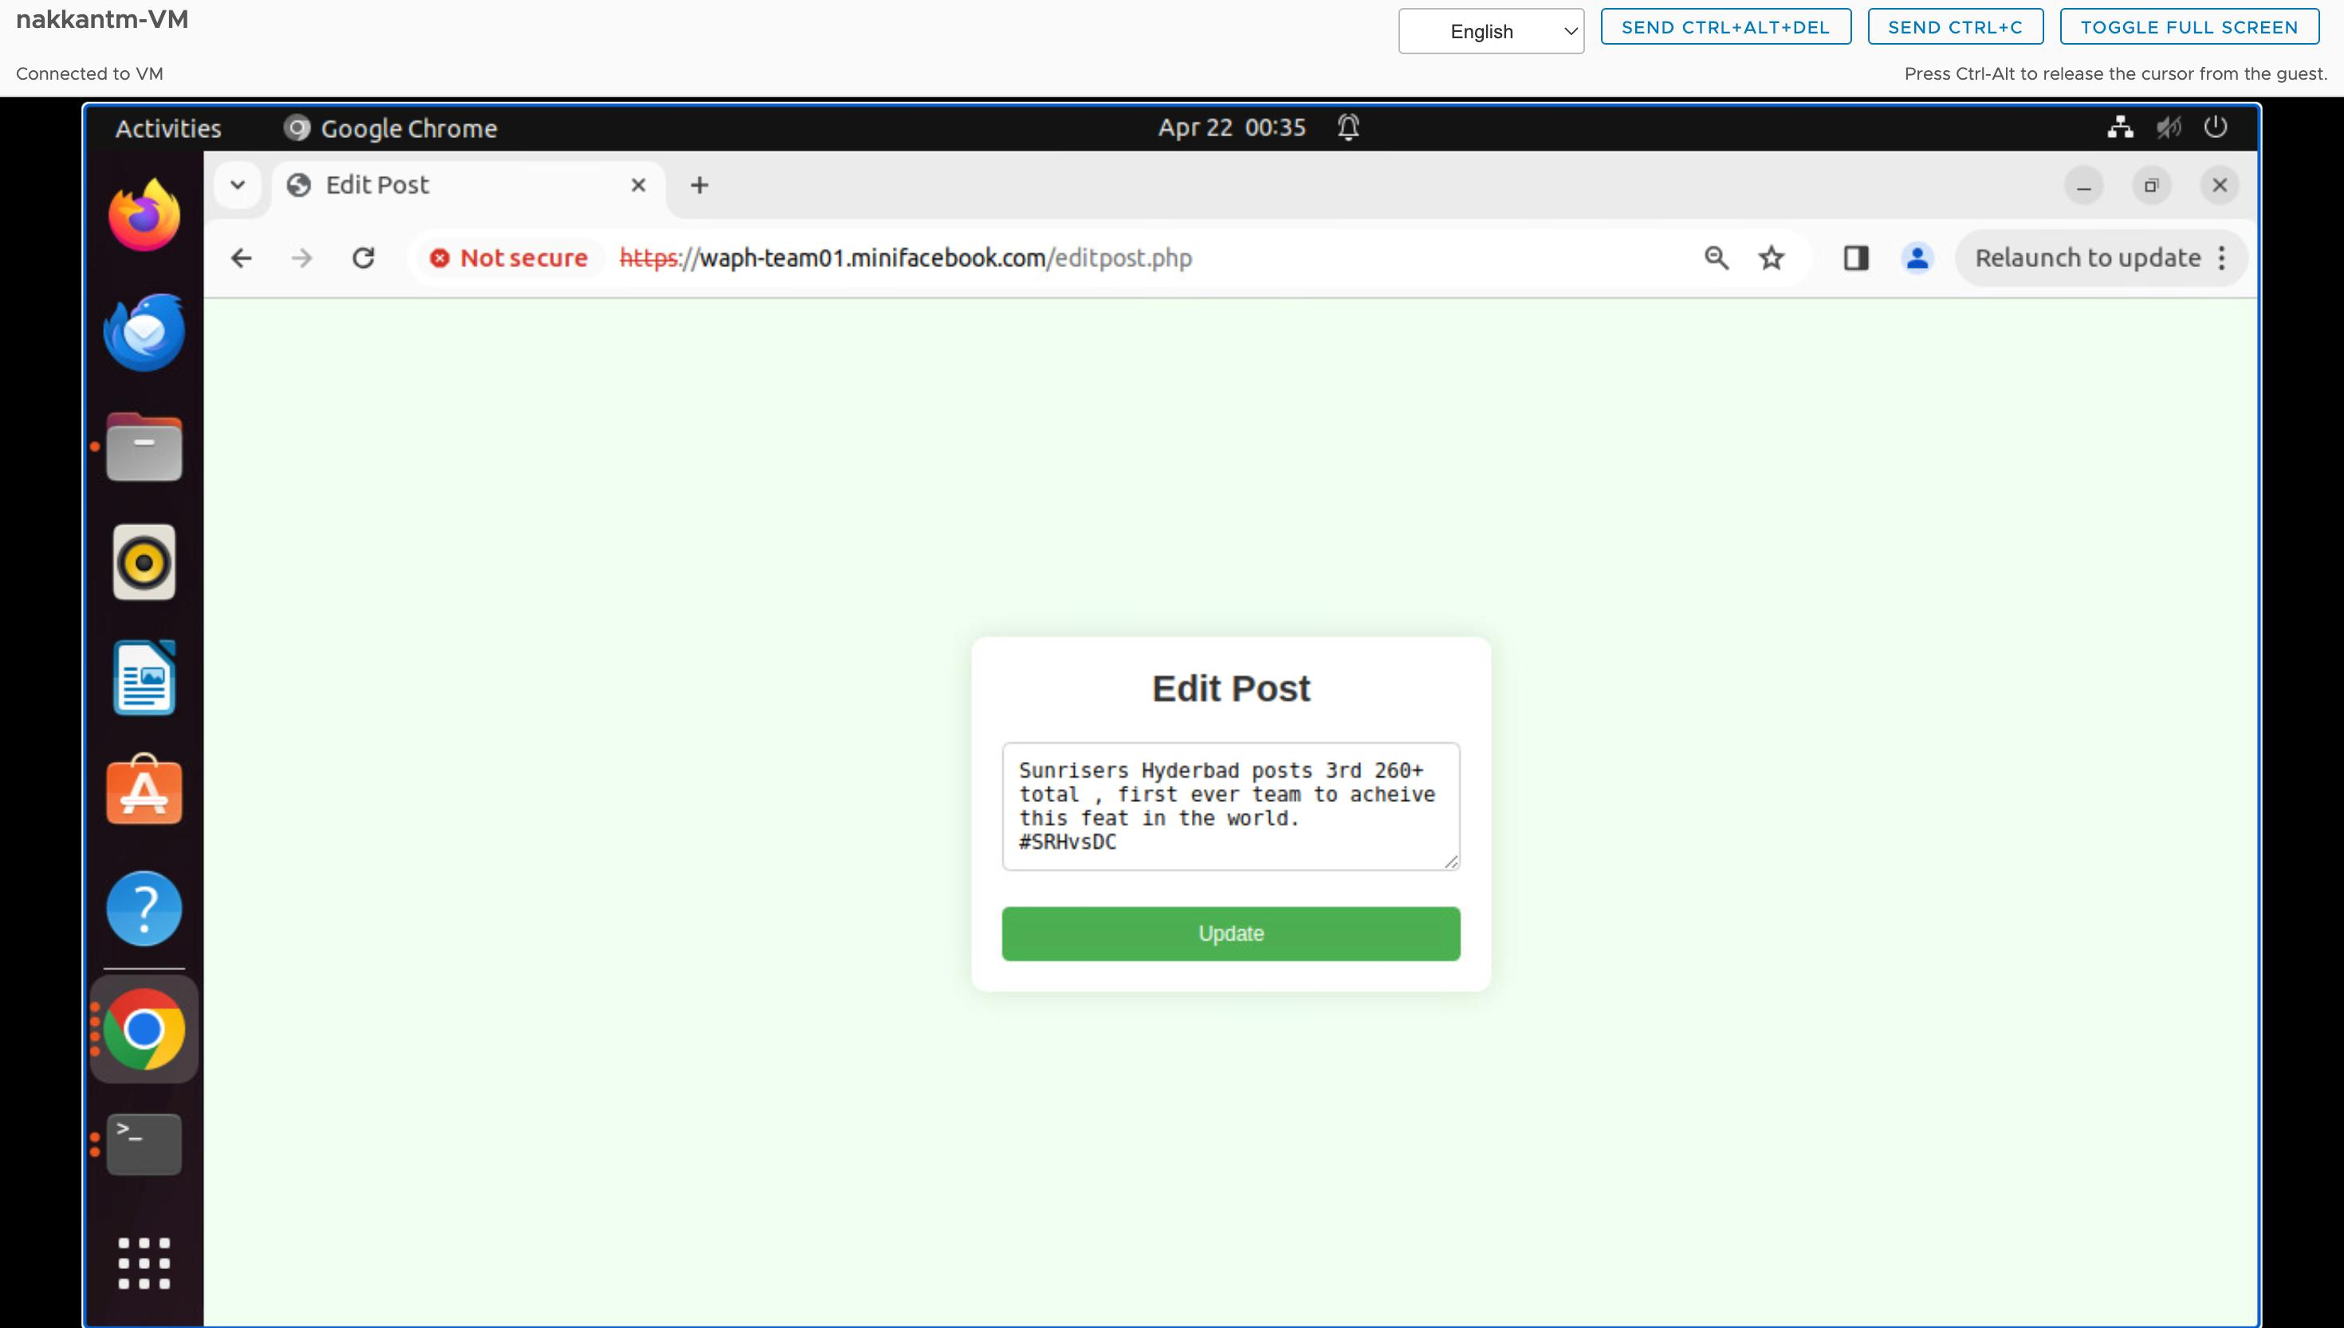

Figure editpost page where user can edit the post

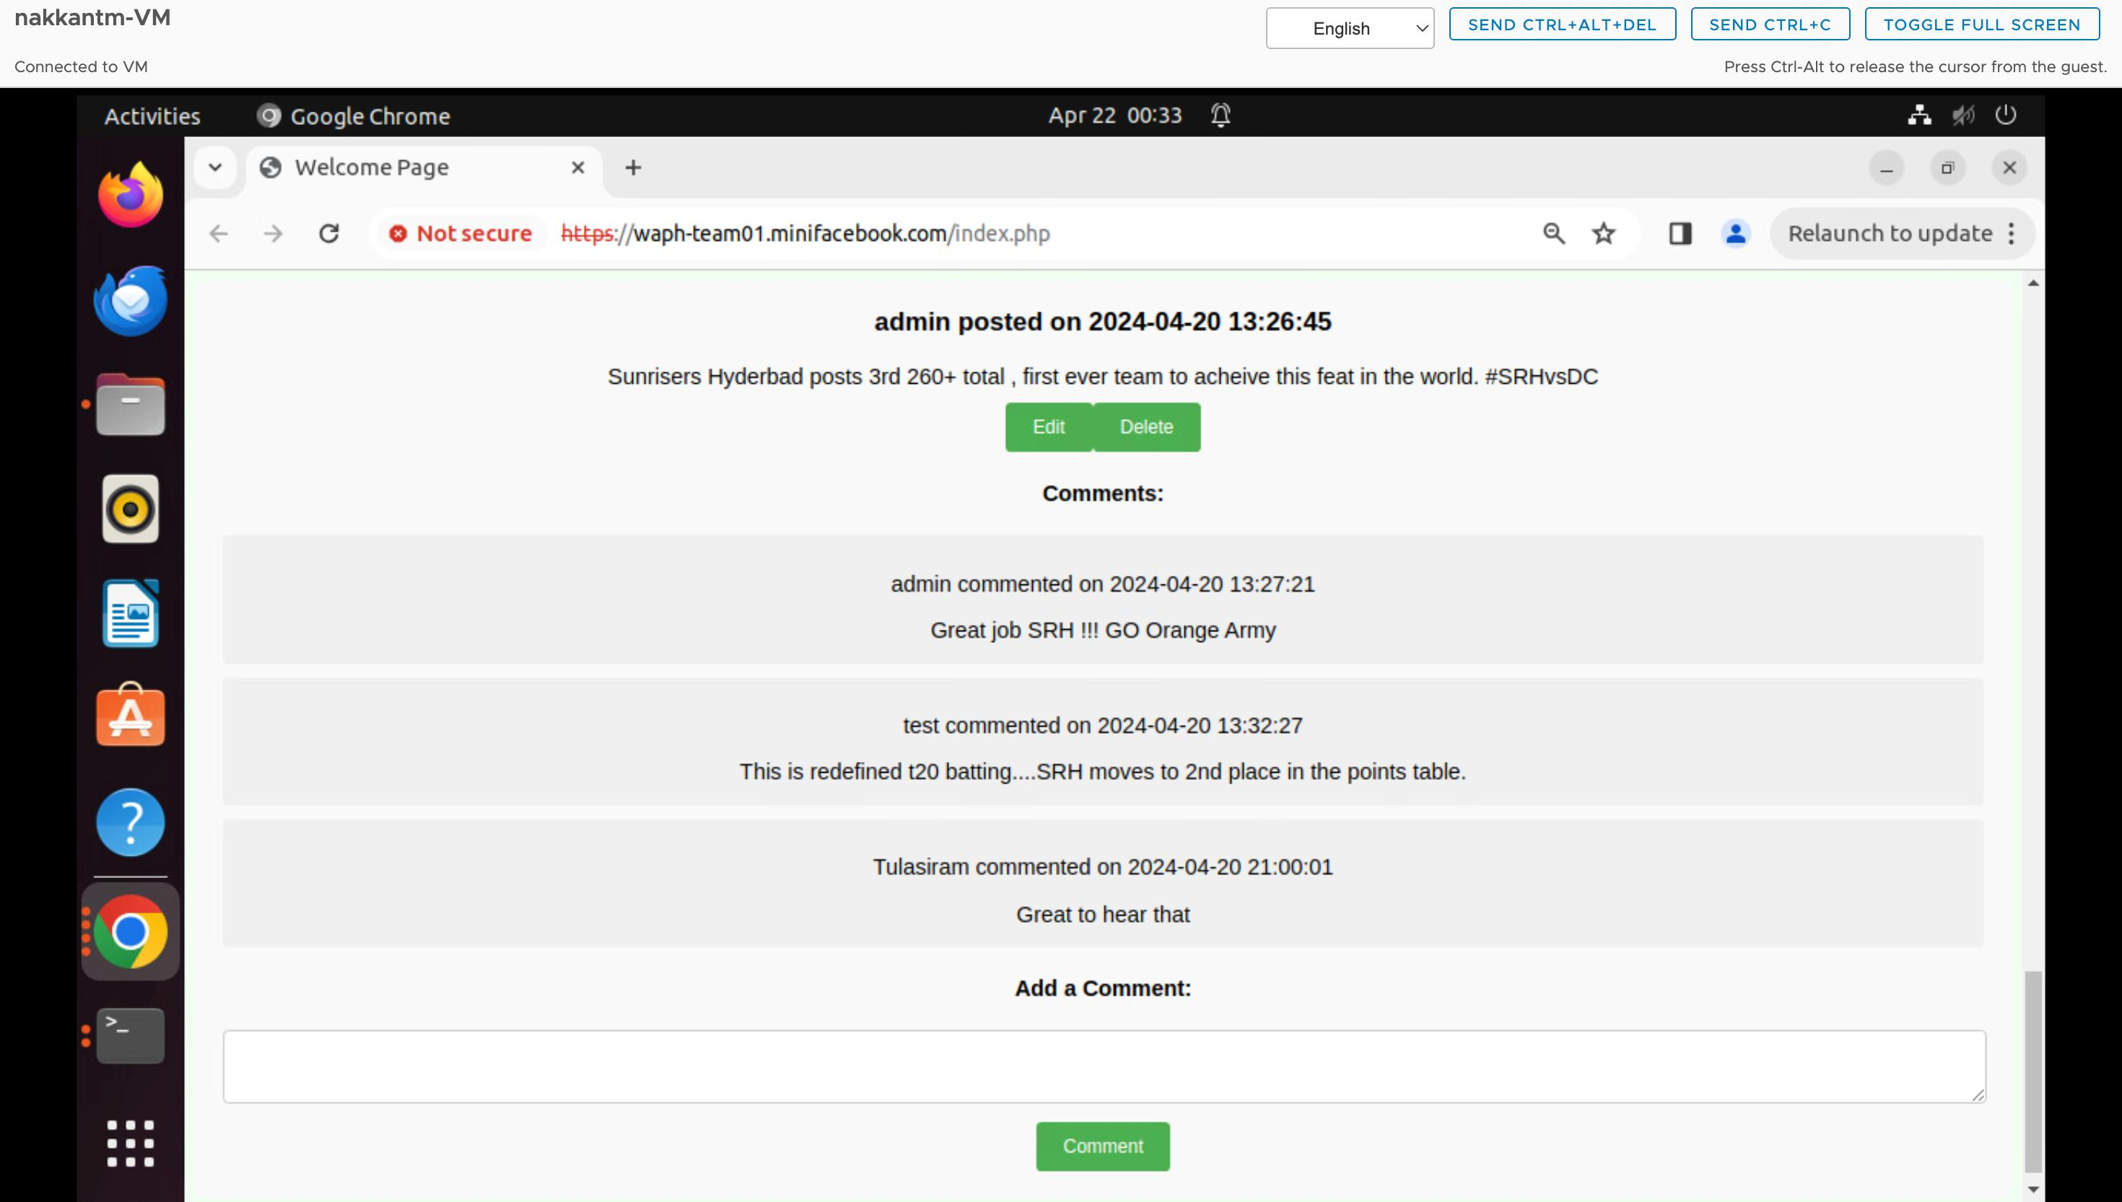

Figure index.php page where user who created the post can edit or delete the post

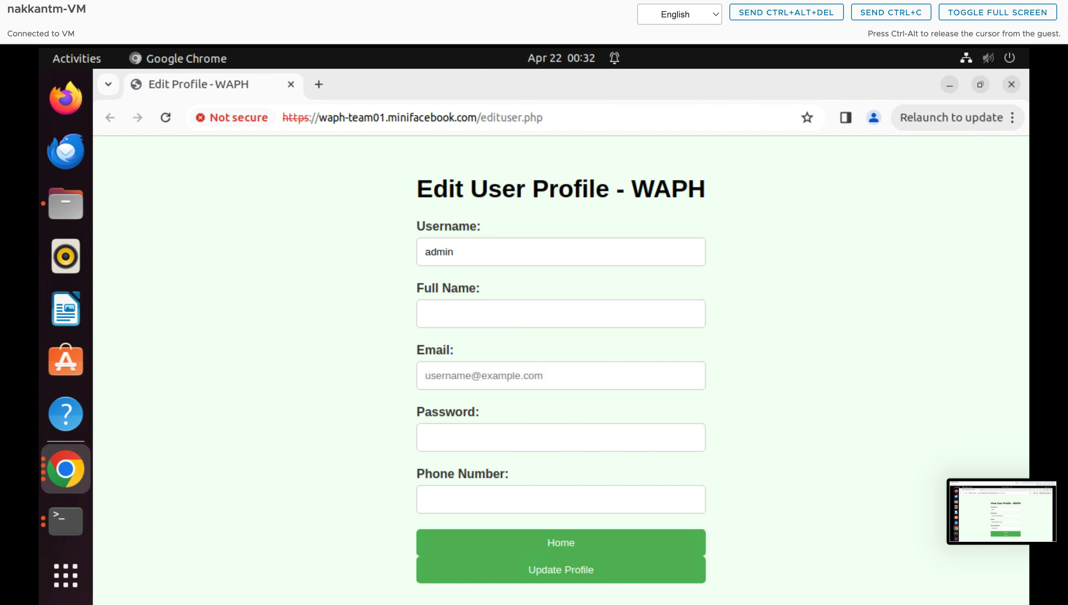

Figure Edituser profile page where user can edit information except the username

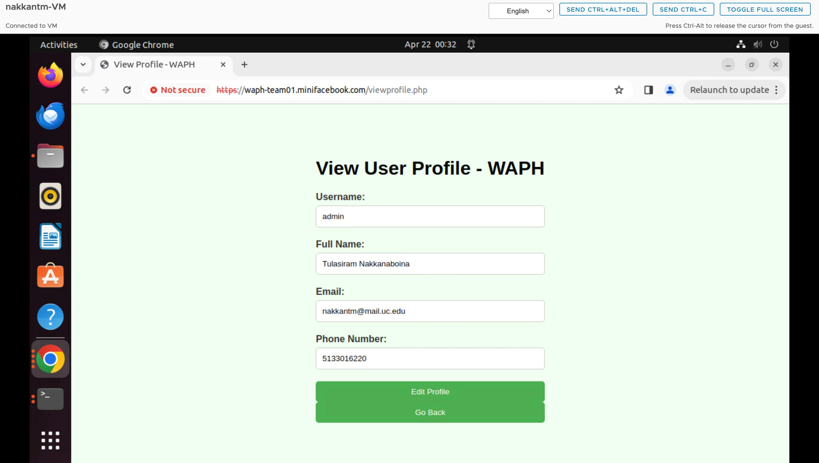

Figure Viewuser profile page where user information can be viewed and non editable

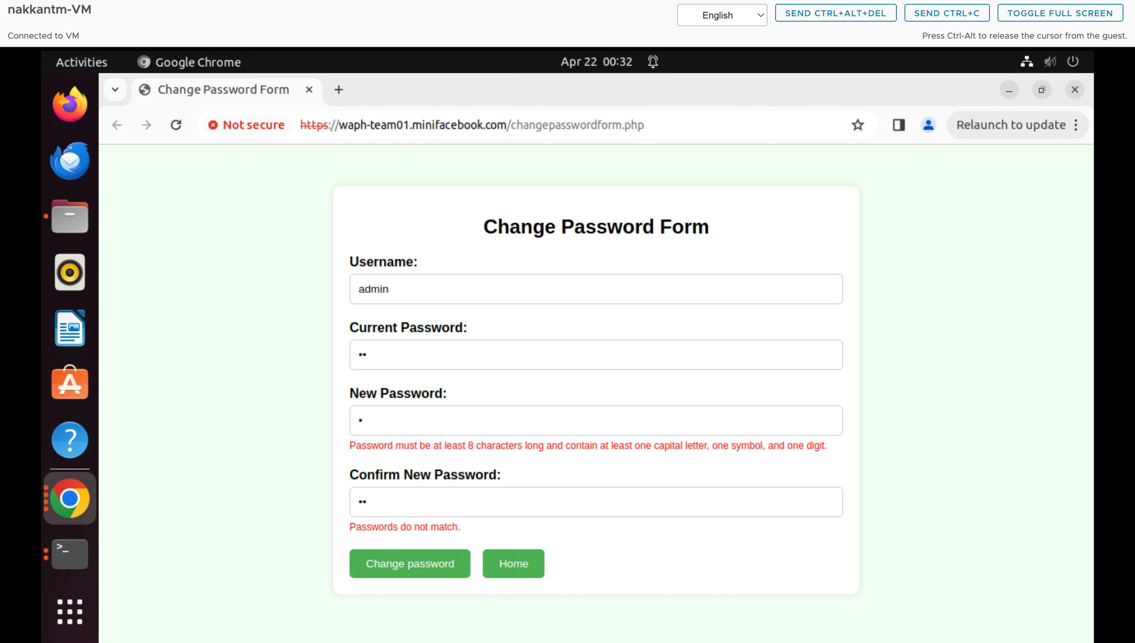

Figure Changepasswordform with instant input validations

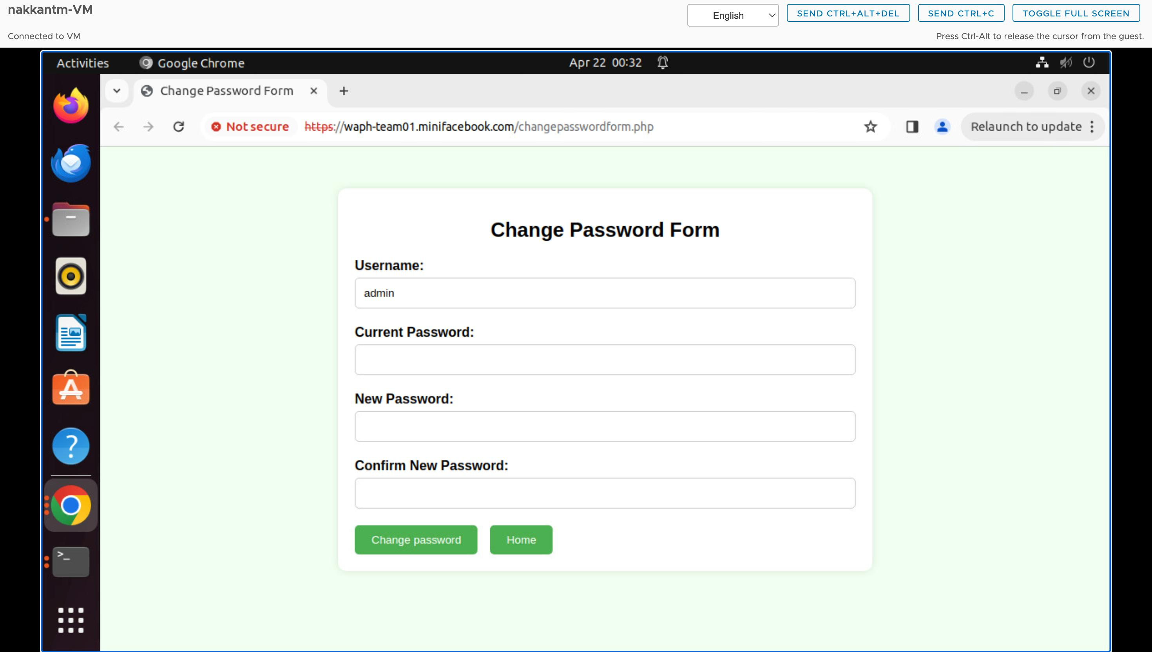

Figure changepasswordform

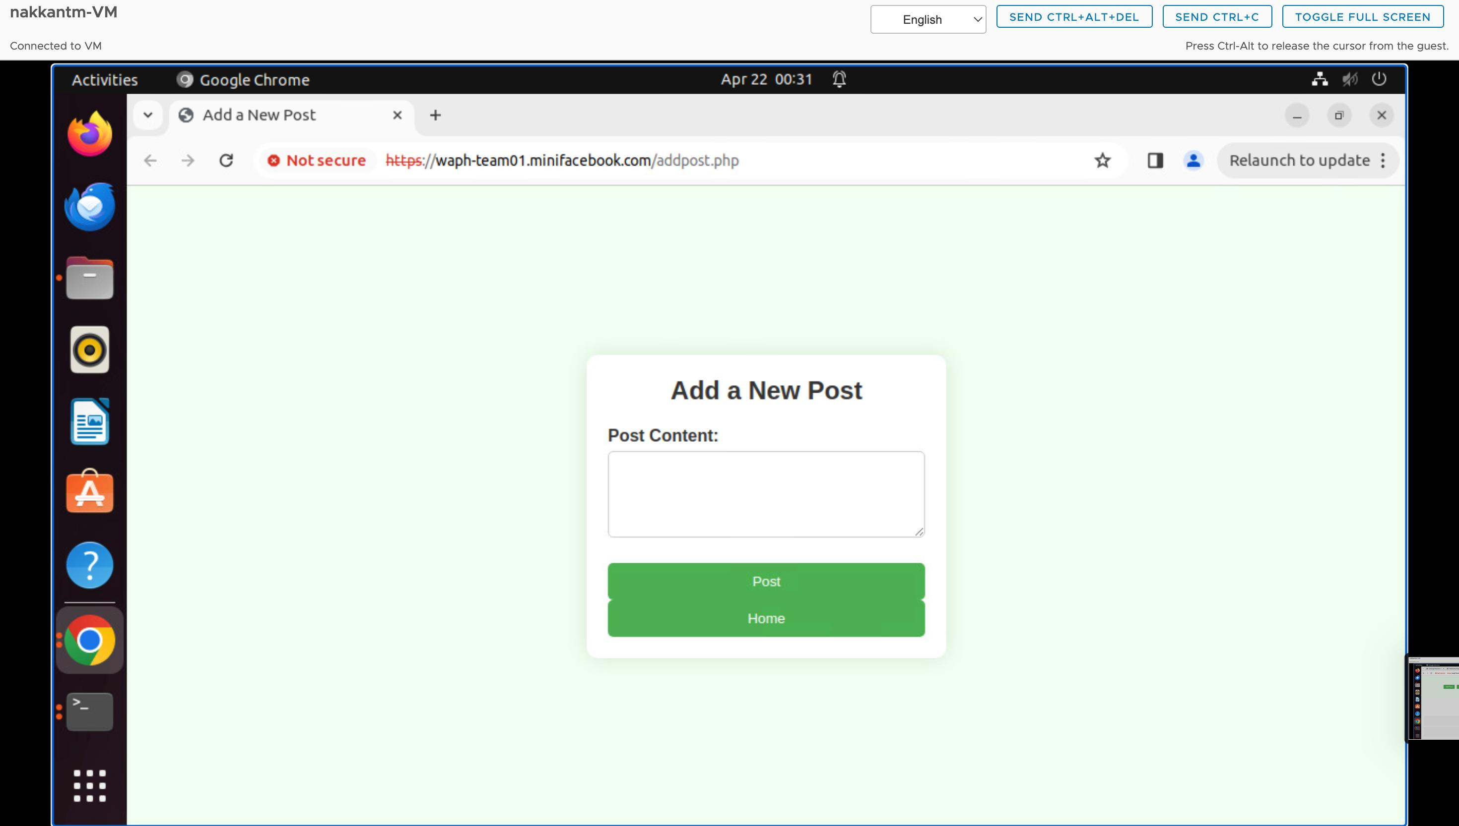

Figure Addnewpost page where user can add a post

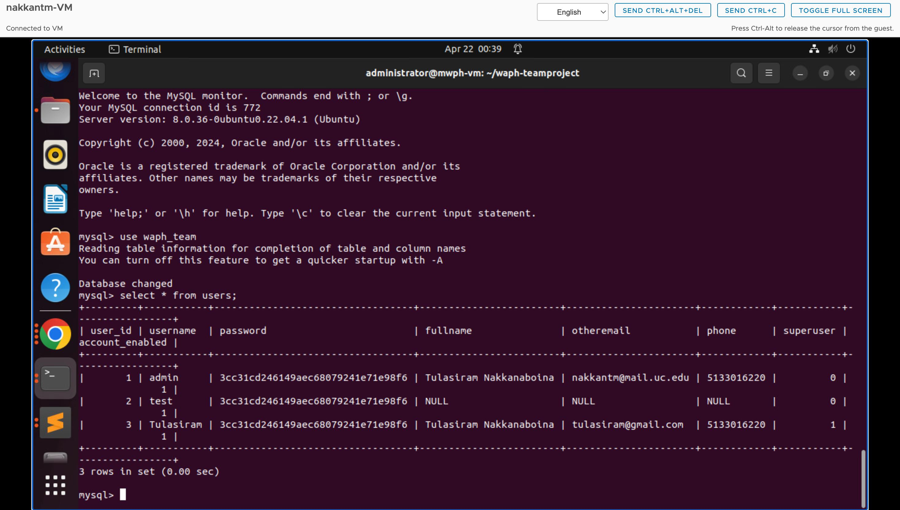

Figure users table

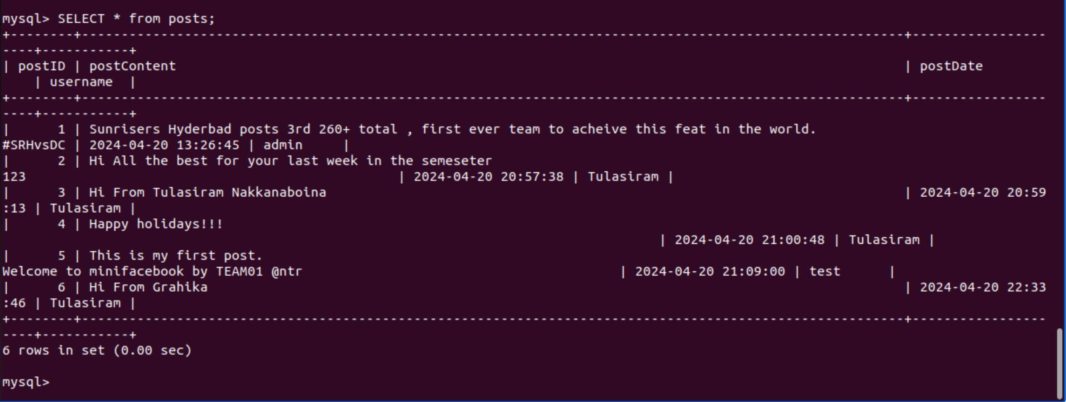

Figure post table

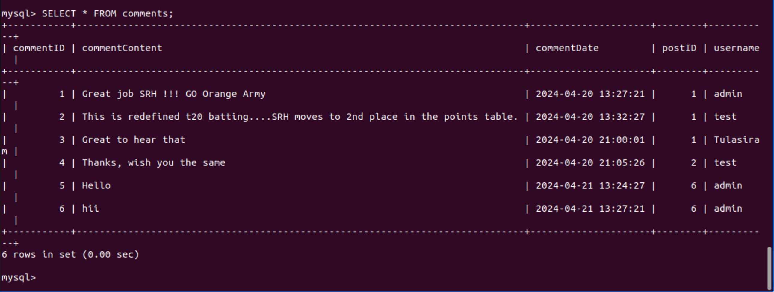

Figure comments table

**Appendix**

**Form.php:**

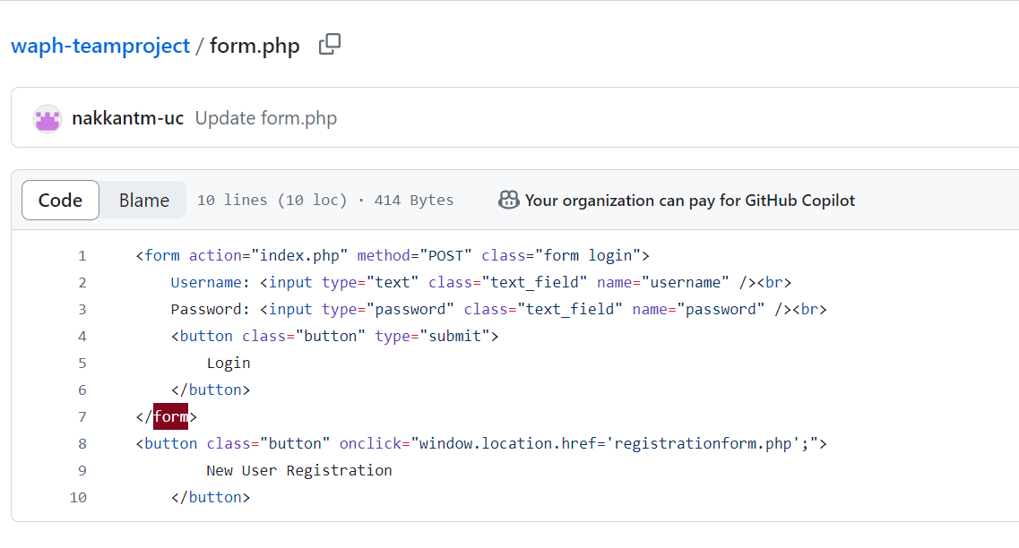

**Index.php:**

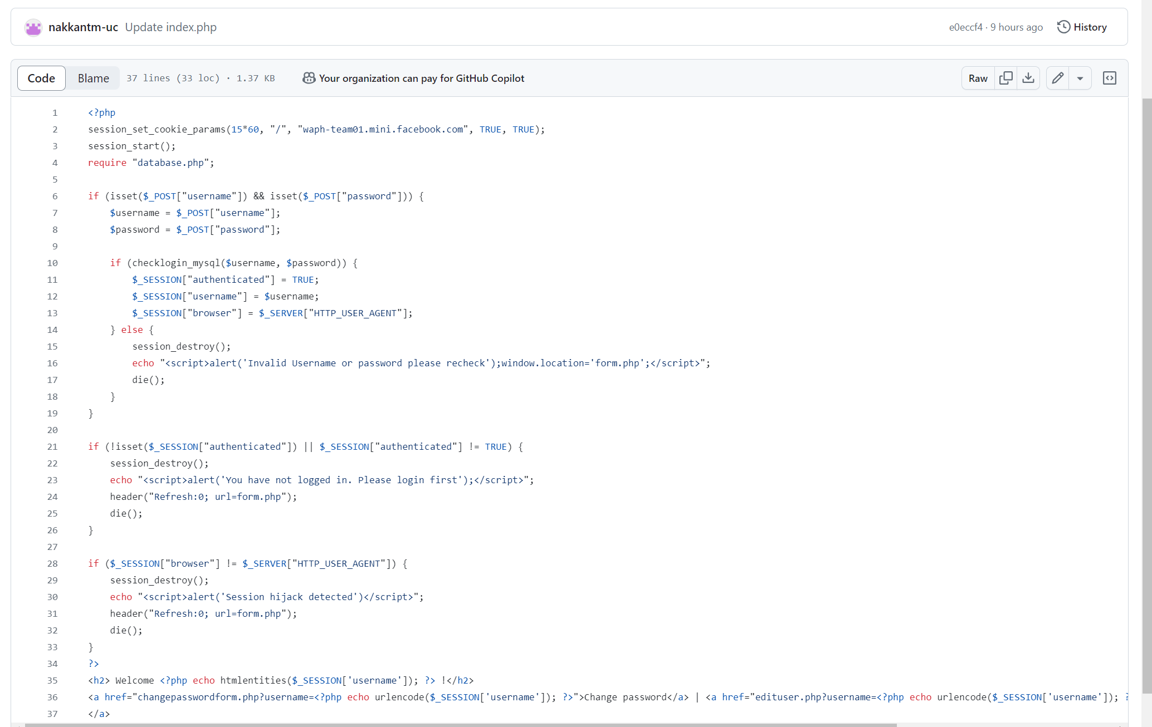

**Changepasswordform.php:**

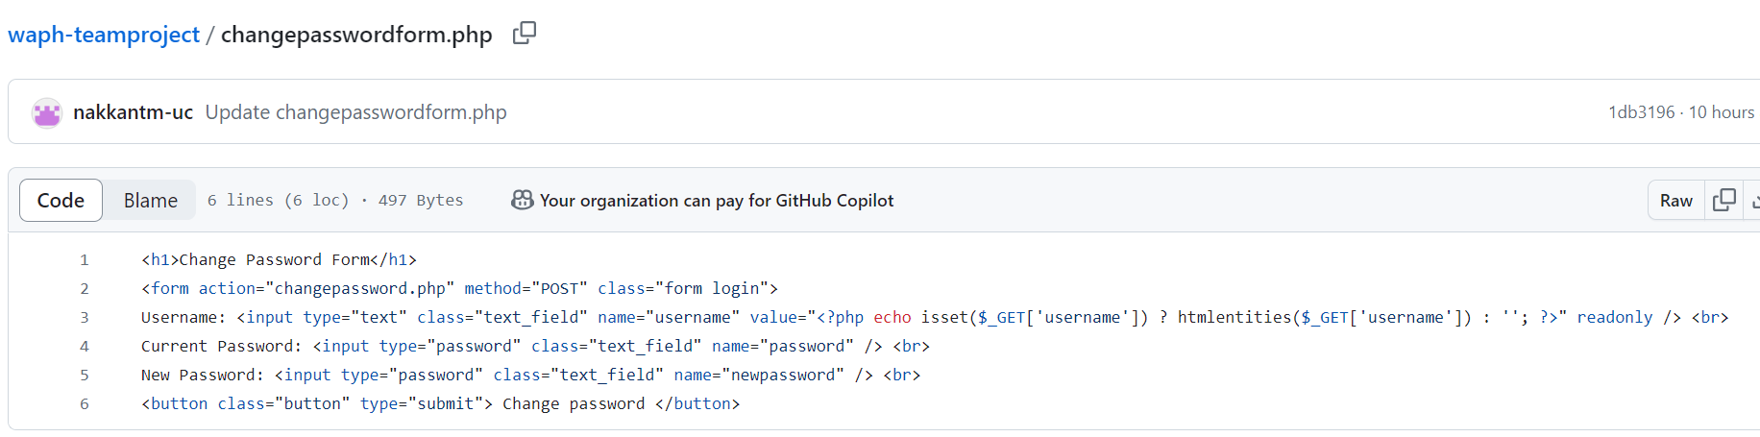

Edituser.php:

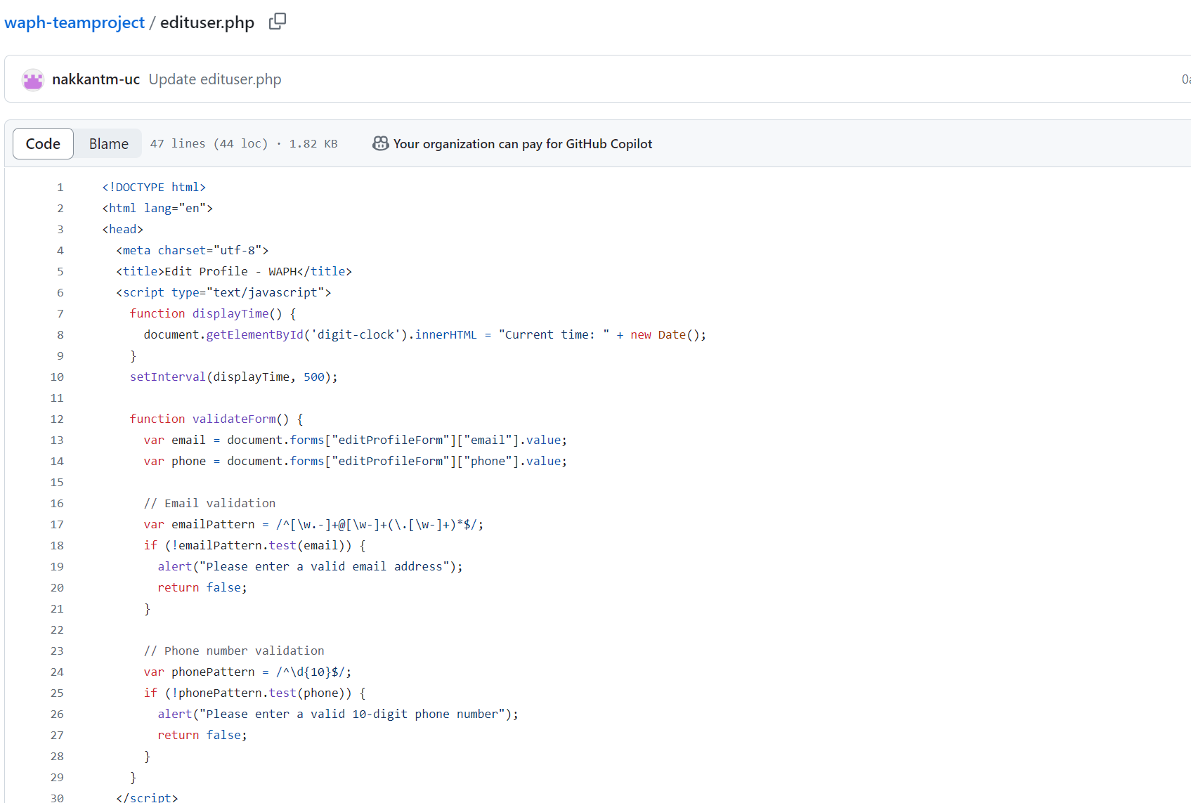

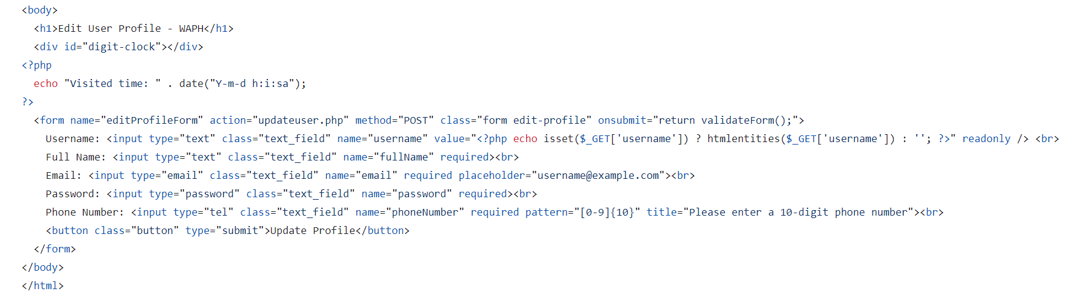

**registrationform.php:**

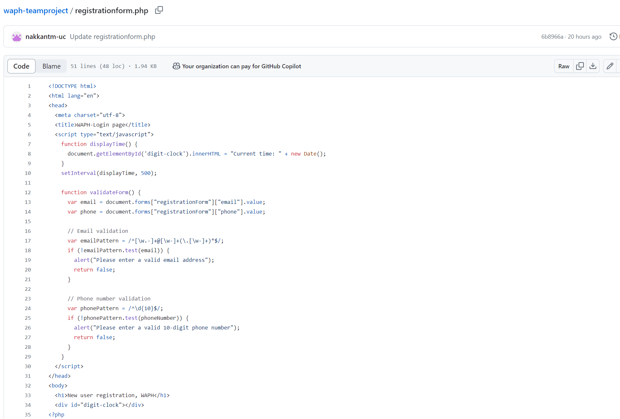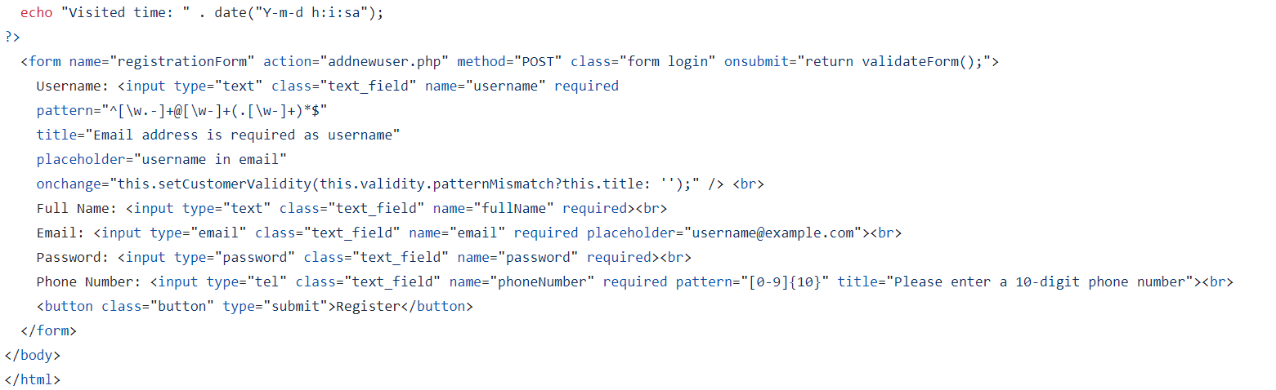

Addcomment.php:

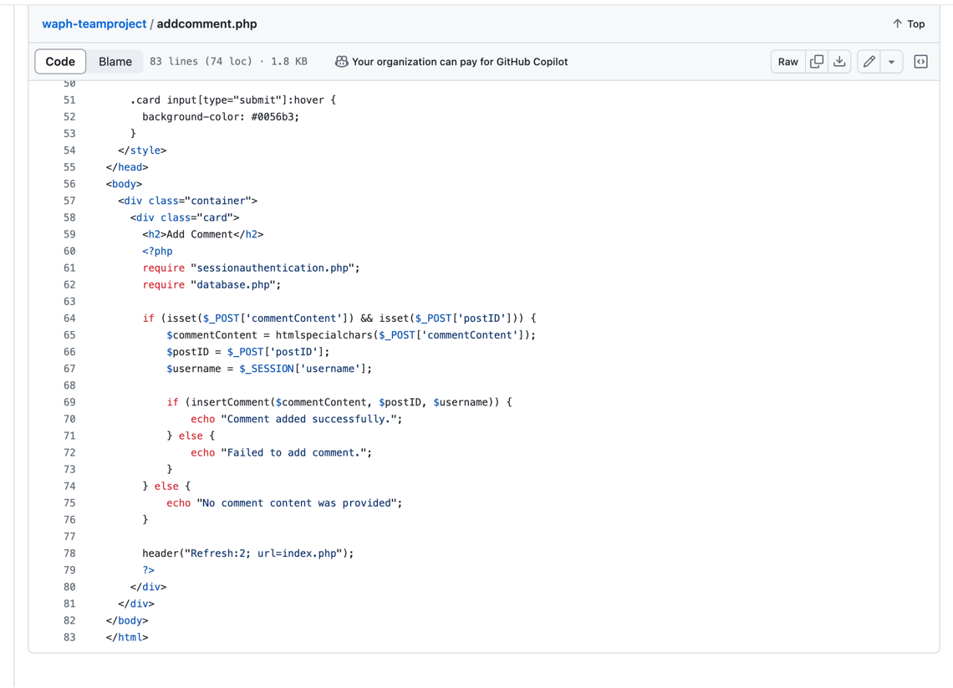

Addpost.php

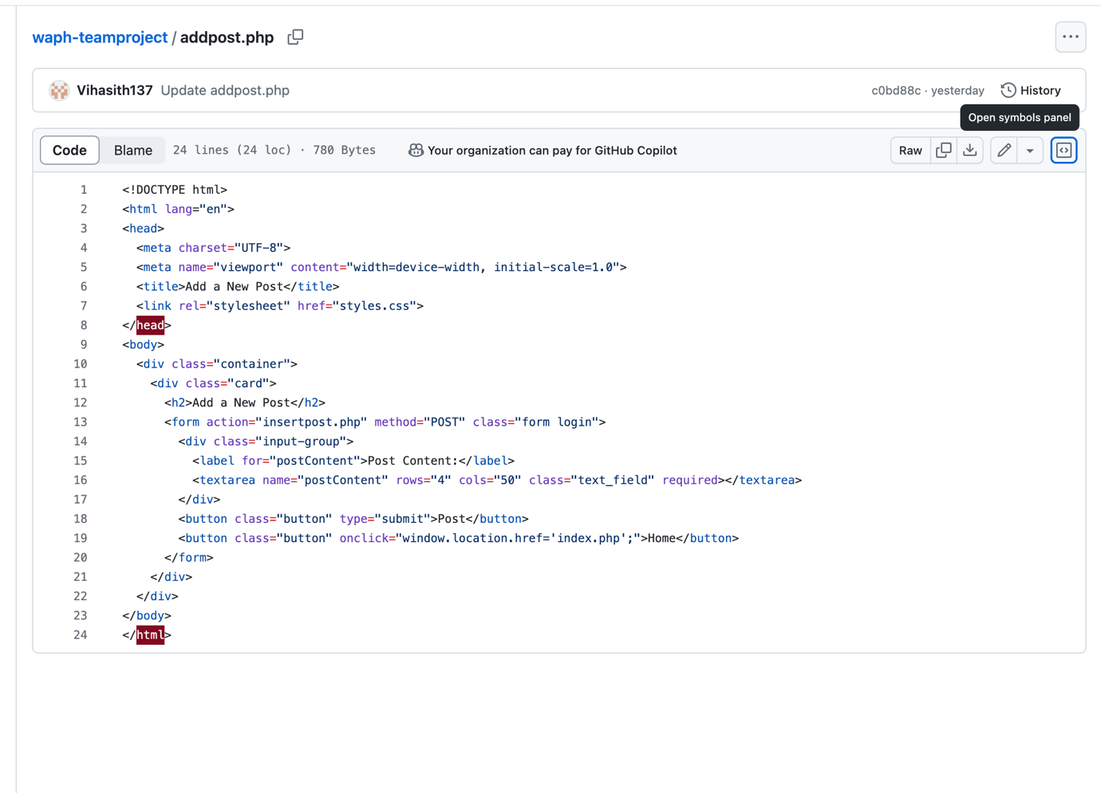

Deletepost.php

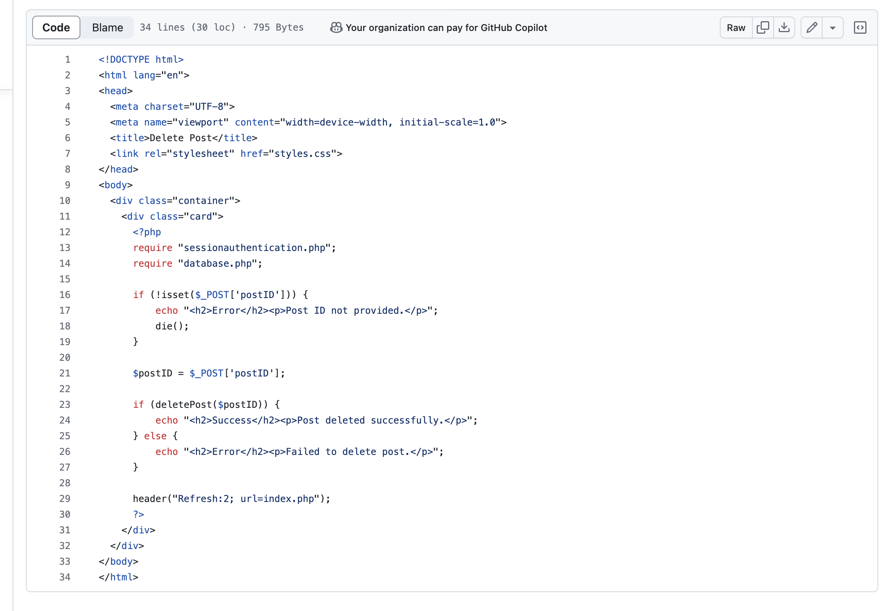

Editpost.php

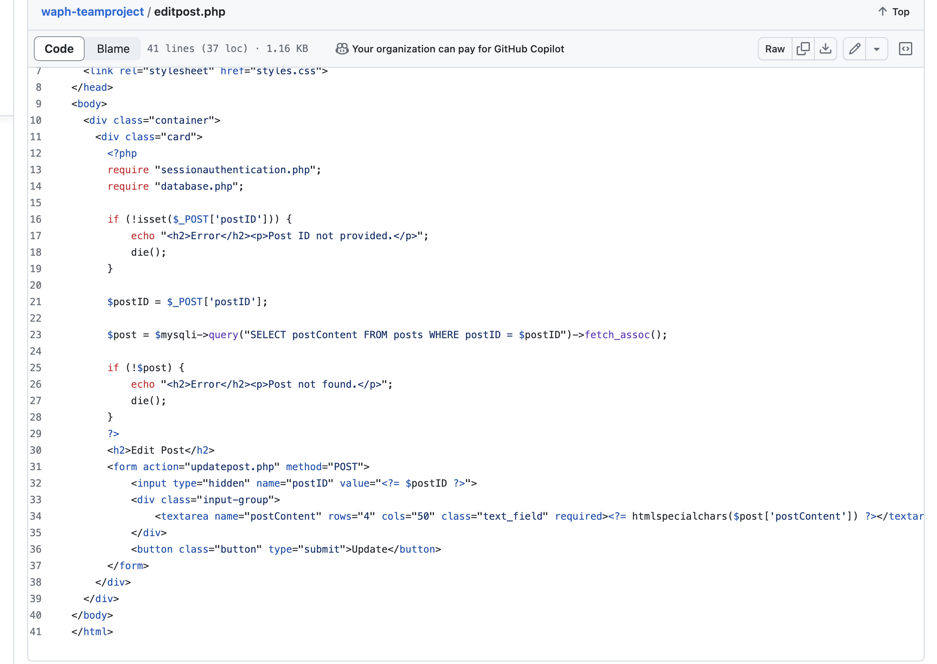

Insertpost.php

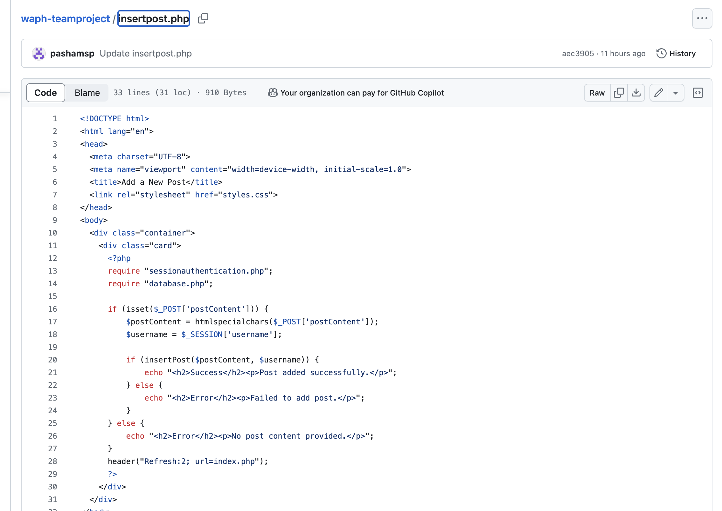

Updatepost.php

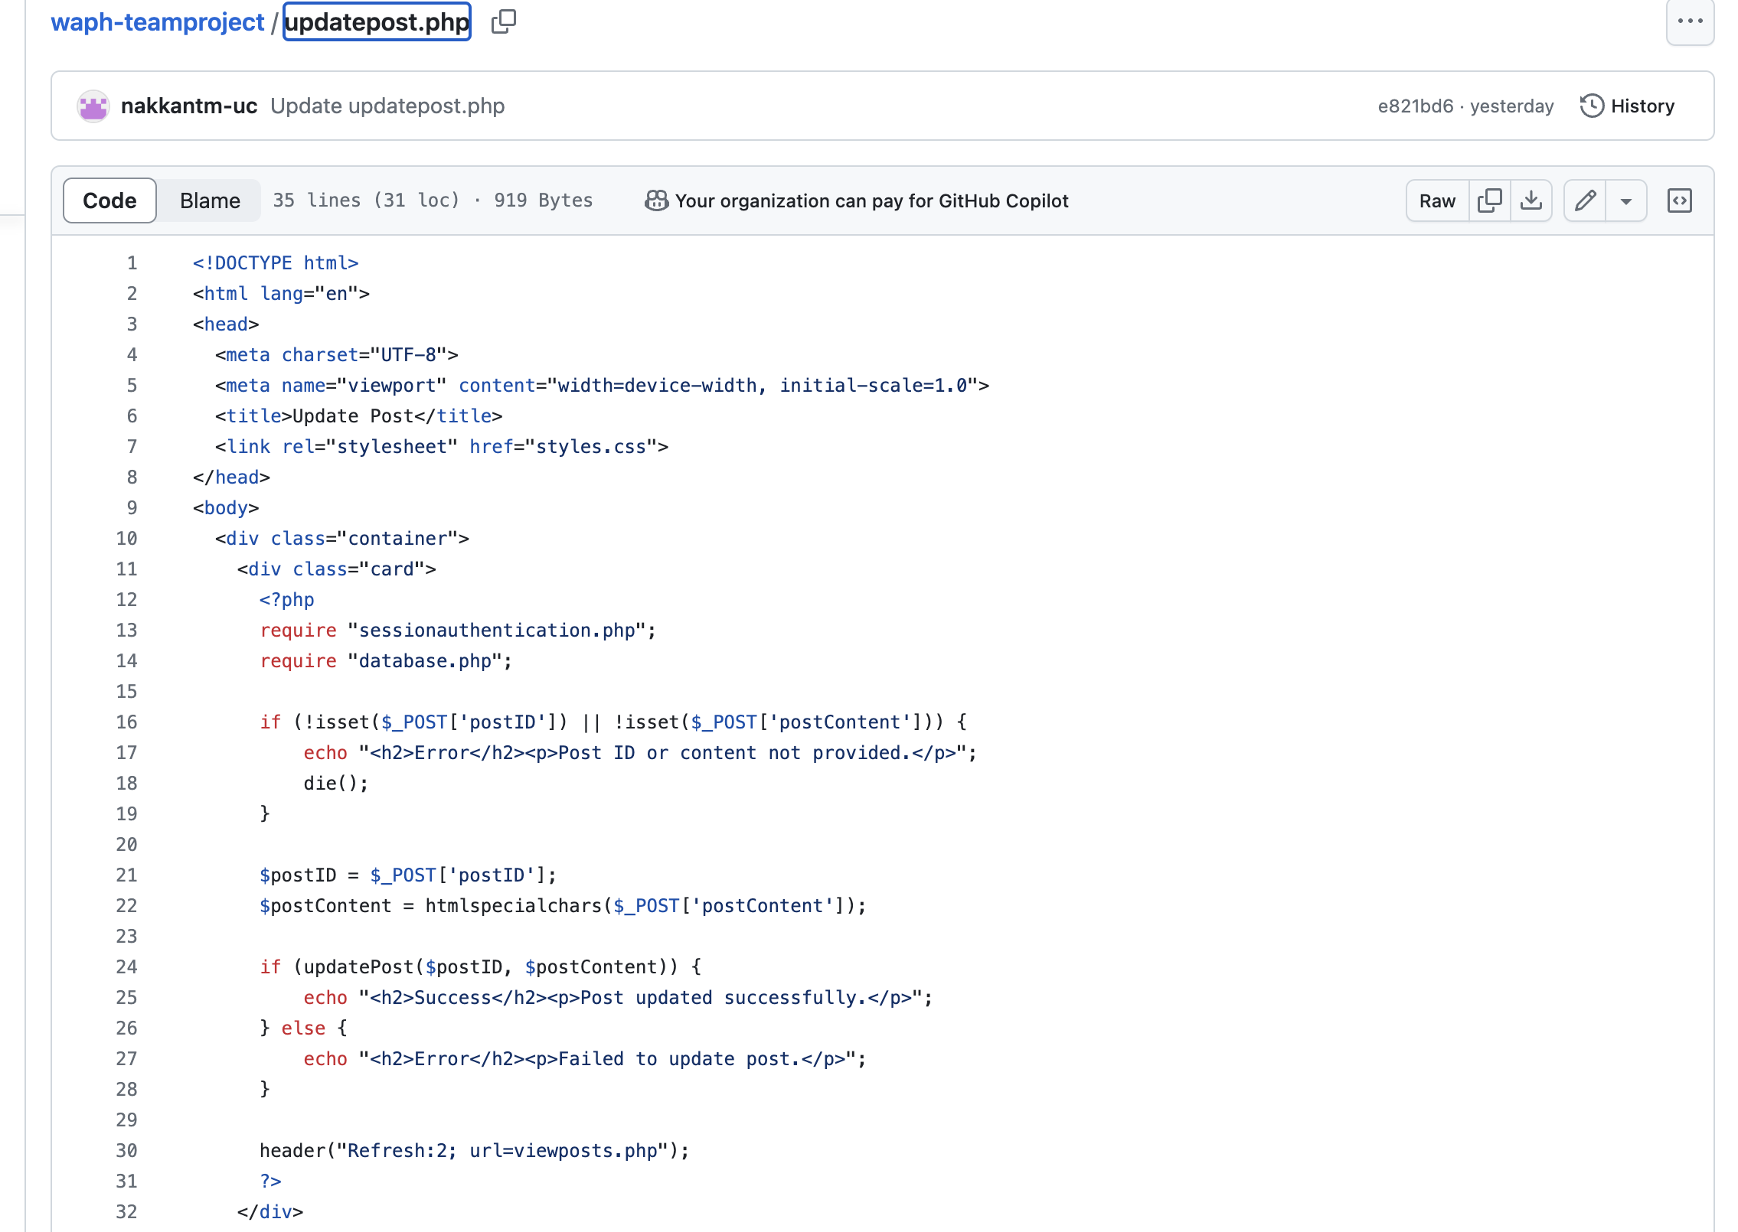

Usermanagement.php

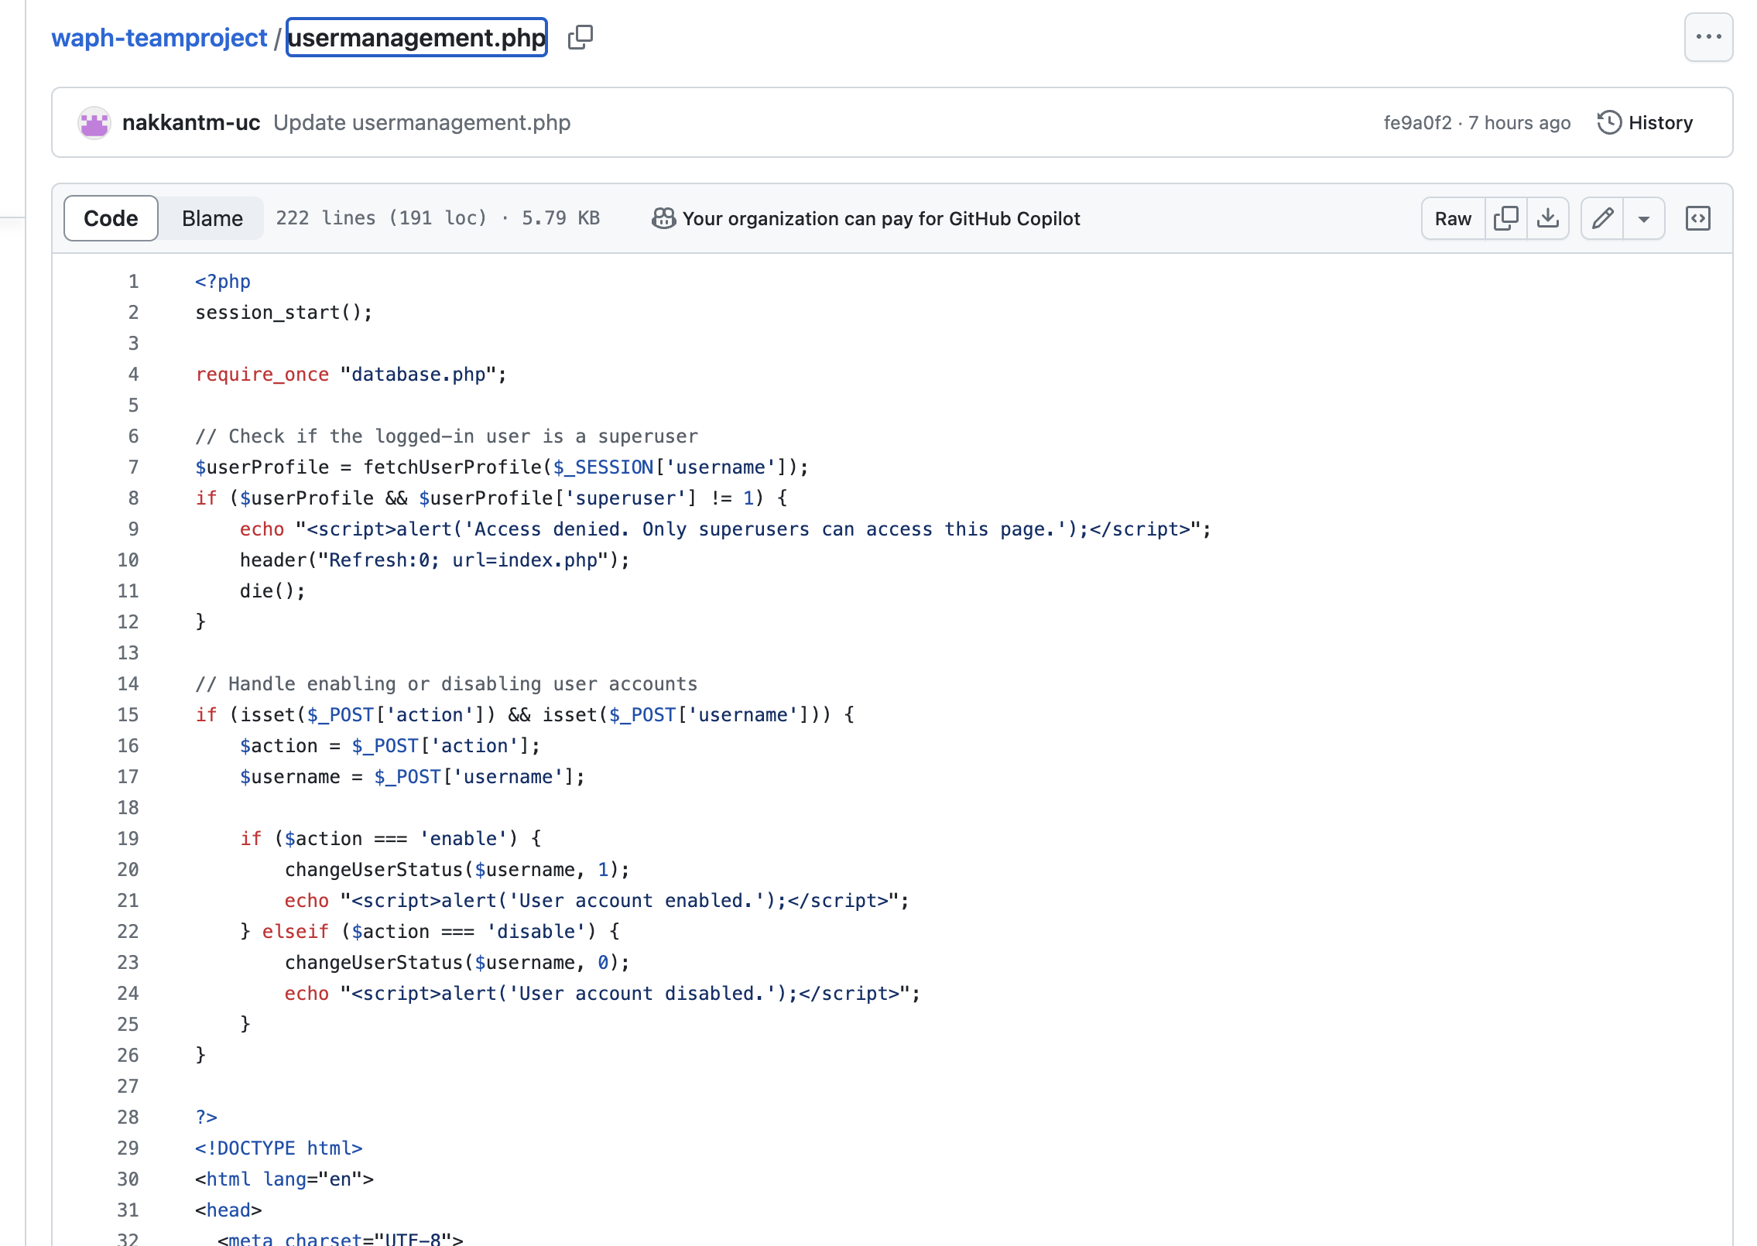

Viewprofile.php

